

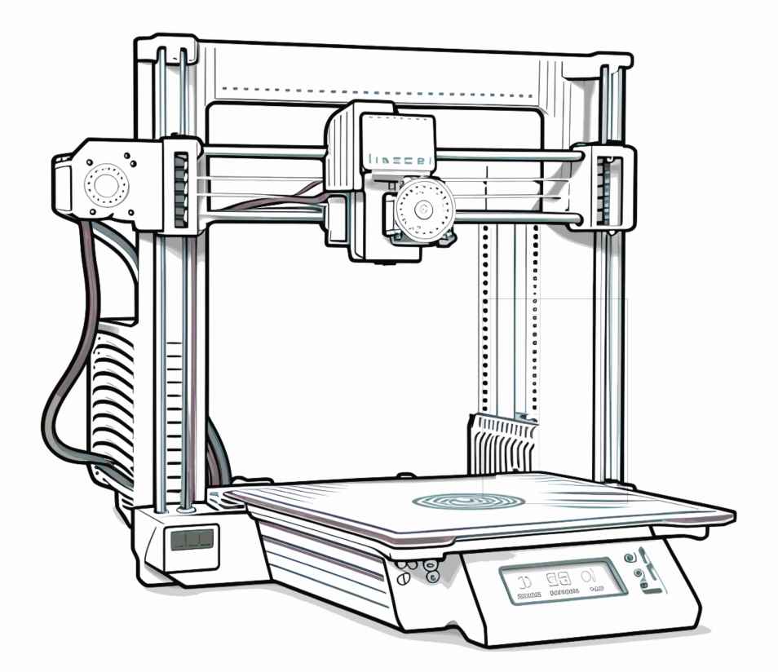

Additive Machine Definition Setup Guide

Purpose: This document is intended to assist the user in creating new FFF printers. This document is for 3D Printers – it does not address milling or turning machines.

This document is part of a collection named PPMS Partner Facilitation.
Copyright © 2025 Autodesk, Inc. All rights reserved
(Note that Table of Contents is made of hyperlinks. If viewing this document in Word, use ctrl+click to jump to pages in the Table of Contents, and use ctrl+home to return to top of document)

Table of Contents
1. Creating a machine Definition for Additive 3
A. Copy and edit 3
B. Start from scratch 4
2. Customize the Machine Definition 4
C. General 5
D. Platform 5
E. Limits 7
F. Extruders 8
G. Post Processing 8
3. User Feedback 9
4. Useful Links 9

Creating a machine Definition for Additive
The Machine Library is used to access existing Machine Definitions, as well as for creating new ones. Both methods are described below.

Copy and edit
As is so often the case, it is easiest to make a copy of something and then edit the copy. You can create your own Machine Definition by copying an existing machine from the Fusion library to your local library.

The picture below shows selecting the Additive filter (2) and then selecting the generic FFF machine. The ‘copy’ icon (4) can be used, and the copy placed into the ‘Local’ (5) folder.

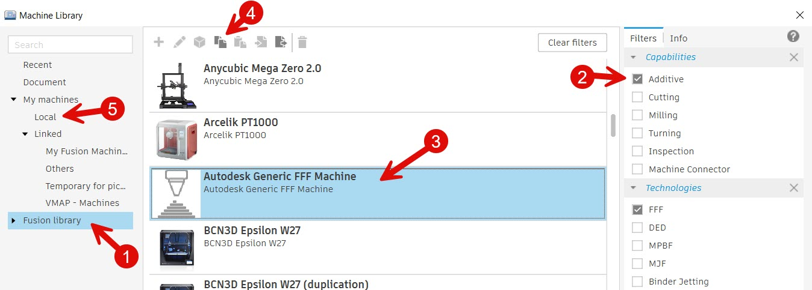

Start from scratch
To start from scratch, use the large ‘Plus sign’ (1) icon as shown in picture below. Select Additive (2) from the pop-down menu.

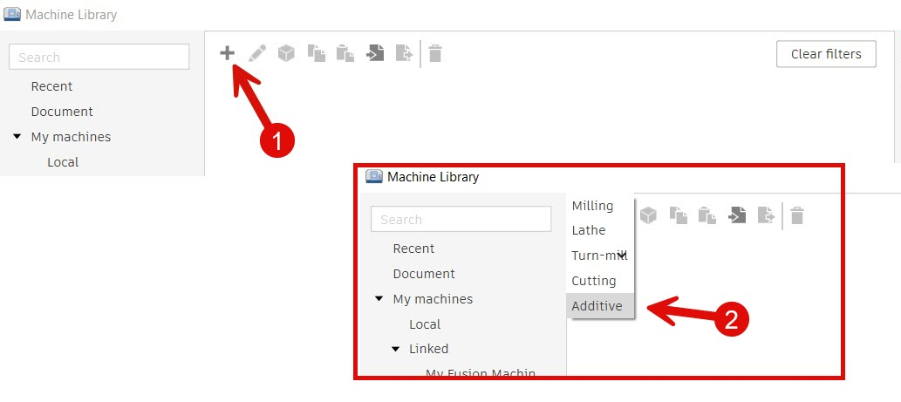

Customize the Machine Definition

If you started by making a copy, or if you started from scratch using the plus sign, you will need to customize the Machine Definition.

Each Machine Definition has a collection of dialog boxes used to supply important parameters and values for Fusion to use. The Machine Definition page has a menu along the left side with selections for the various groups of data.

This document has a section for each item on that menu. The first is the ‘General’ menu item as shown in the picture below.

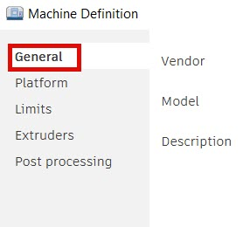

General
Vendor and Model fields – use them to create the name shown in the list of Machine Definitons. It can be tempting to leave the fields as they are, but it is recommended you take the time to adjust these. In the pictures below you can see how fields ‘Vendor’ and ‘Model’ are combined to make the name shown in the Machine Library. Setting this name and description will help you find and choose Machine Definitons in the future.

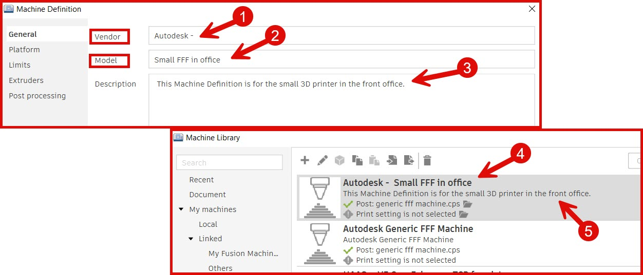

Platform
The second item down on the left menu is ‘Platform’. It has fields for setting a machines dimensional limits, origin, and no build zones. The tool tips that pop-up when you hover over the fields help explain each field.

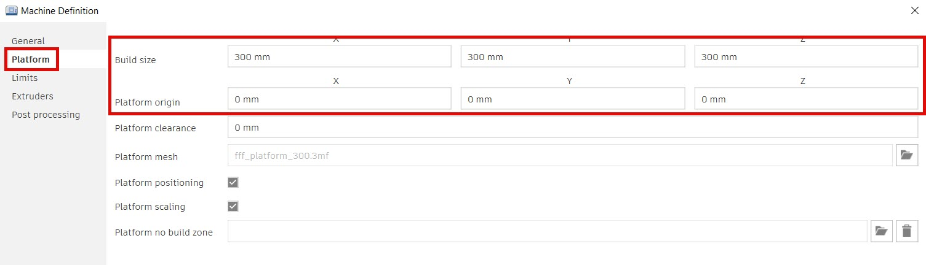

The origin of FFF printers, the X0 Y0 Z0 position, is normaly the bottom lower left corner of the platform. When the origin is the center of the platform the X and Y values need to be half the platform size.
The picture below shows the platform model and scaling settings that correlate to the Build size and Platform origin in Fusion.

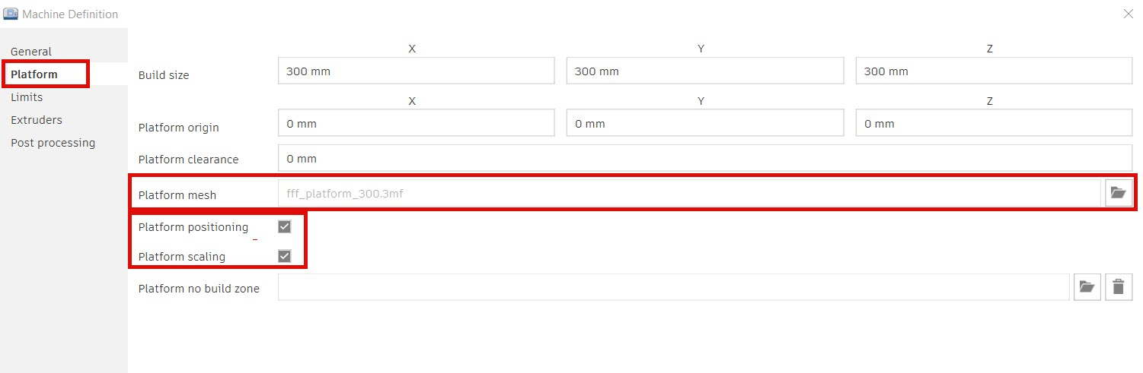

If you use the ‘Platform mesh’ field to import your own ‘Platform’ and you want to keep the origional dimension and position, you have to uncheck the ‘Platform positioning’ toggle.

The files you can specify in the ‘Platform mesh’ field have the ‘.3mf’ file extension as shown in the picture below.
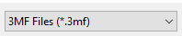

Limits
If you want to define an area where the printer should avoid, use the ‘Platform no build zone’ field shown below to supply a ‘.3mf’ file of that zone.

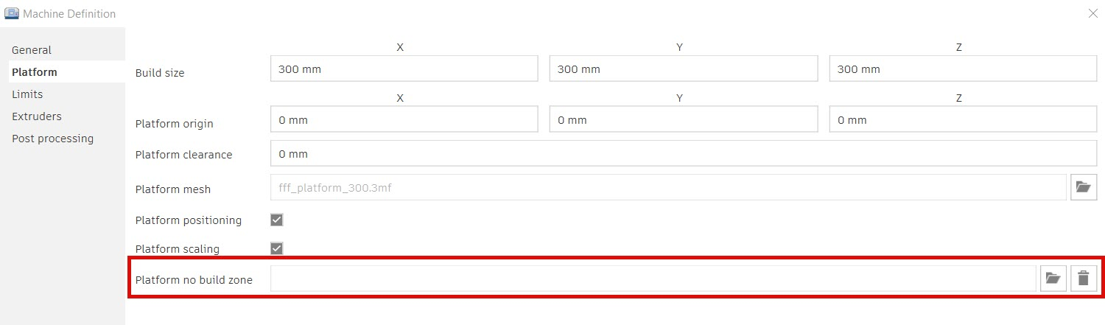

The third item down on the left menu is ‘Limits’. It has a variety of fields for setting key machine data. Again, the tool tips that pop-up when you hover over the fields help explain each field.

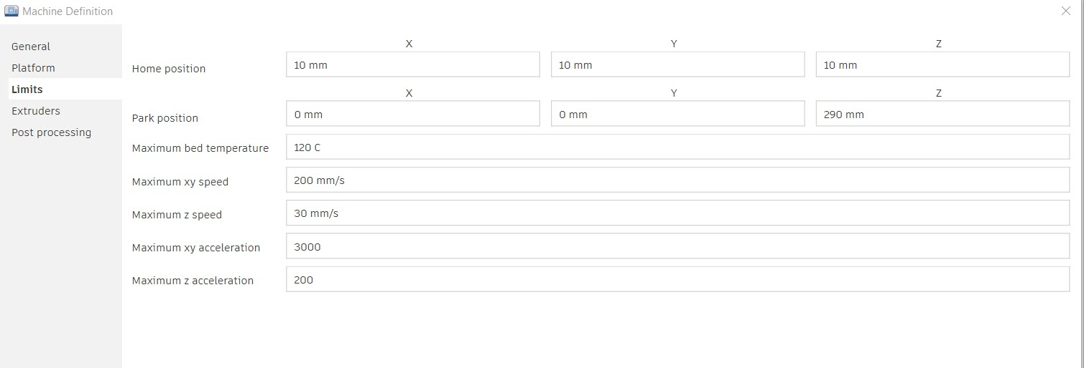

Note that some of the defult values in these fields are unrealisticly high. For example ‘Maximum bed temperature’ is set high enough to not limit the values selected in print settings.

Extruders
This dialog is where the setting for extruders can be set, and additional extruders can be added. The plus sign (1) and the trash can (2) icons shown in the picture below are used to add and remove additional extruders so the numbers match the machine.

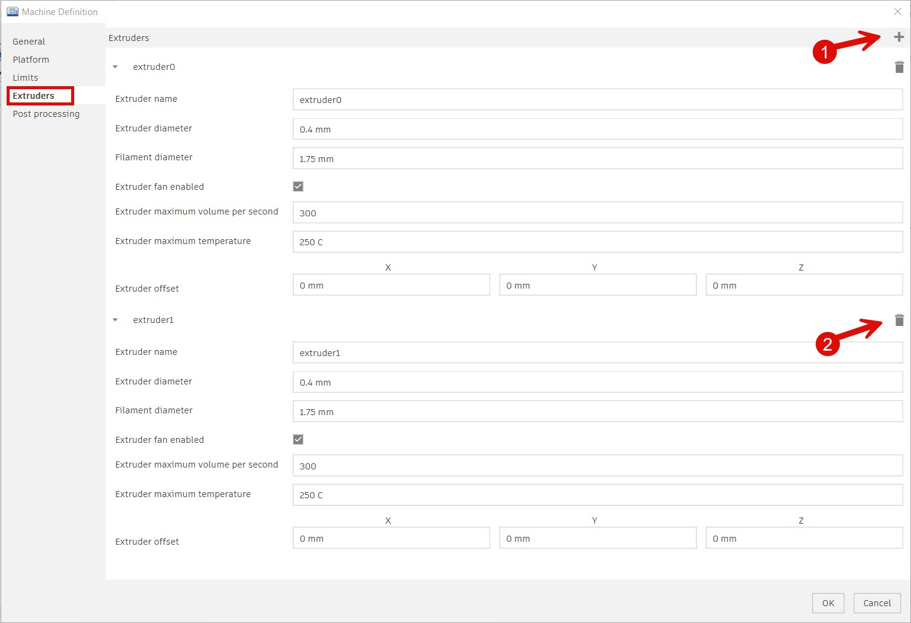

Post Processing
As you probably guessed, the post processor dialog is used to set the post processor you want to use for creating your NC code output. There are fields for setting the folder where the code file should be placed by Fusion.

Depending on the post processor that is selected, the fields for ‘Post Properties’ and ‘Machine setting’ can be used.

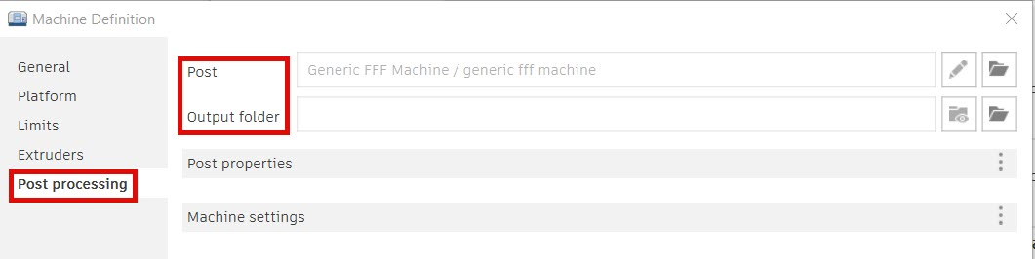

User Feedback
If you would like to provide us with feedback on this document, or suggestions for other documents like this, please send email to:

channel.posts@autodesk.com

Please set the subject of the email to read: Feedback on 3-D Printer additive

Useful Links
The links below provide additional information and instructions on related subjects.

Newly authored, comprehensive information:
Post Processing and Postprocessor Properties for FFF
https://www.autodesk.com/products/fusion-360/blog/post-processing-fff-printers-autodesk-fusion/

The Autodesk App store – apps created for Fusion :
https://apps.autodesk.com/FUSION/en/Home/Index

The Additive Assistant – for FFF guidance and analyses of your designs
https://apps.autodesk.com/FUSION/en/Detail/Index?id=9068625559069345798&appLang=en&os=Win64

Older but still useful video - Create your own machine & post
TUTORIAL: Creating a custom machine & post processor for FFF (3D printing) in Fusion 360

